www.aioucheats.com Free Solved Assignments of Autumn 2013 Semester and Old Papers of Allama Iqbal Open University. Guess Papers and Helping Keybooks are also available. We provide all stuff Free of Cost. ☺
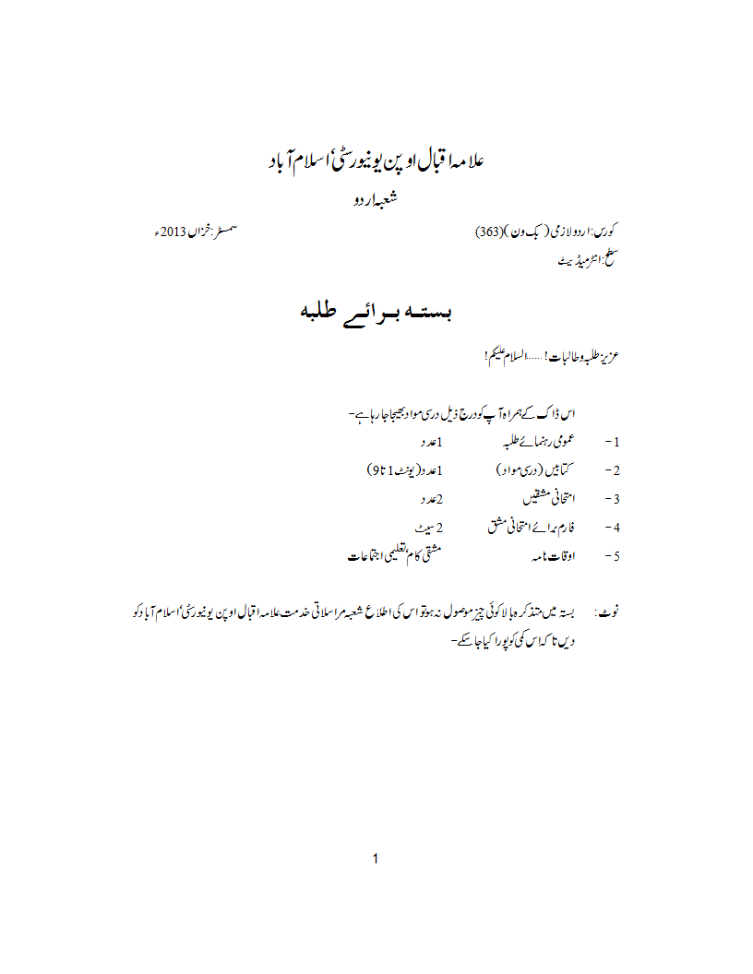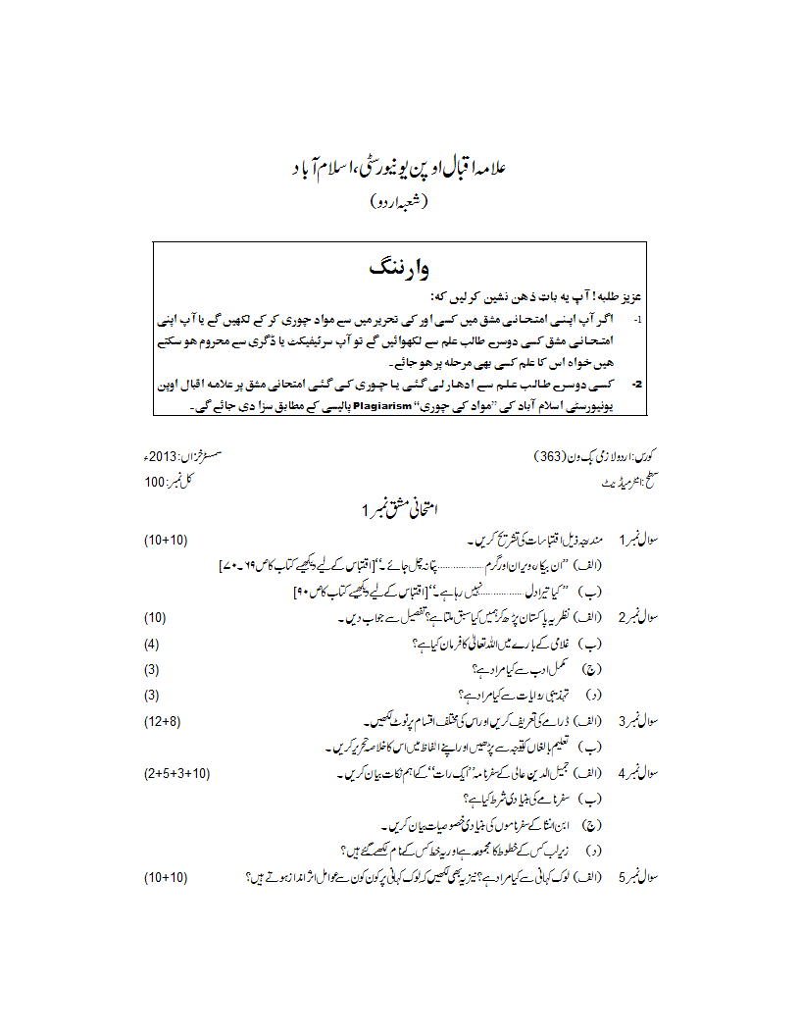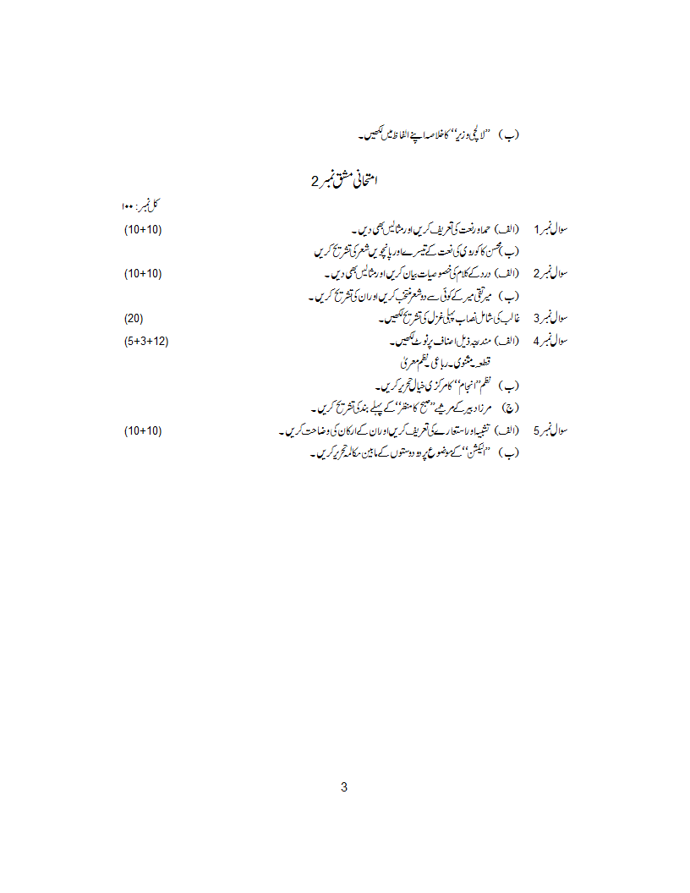www.aioucheats.com Free Solved Assignments of Autumn 2013 Semester and Old Papers of Allama Iqbal Open University. Guess Papers and Helping Keybooks are also available. We provide all stuff Free of Cost. ☺

